Practical - 4

**Aim: - Packet capturing and network scanning using Wireshark.**

**Wireshark: -**

* Wireshark is a free and open source packet analyzer.
* It is used for network troubleshooting, analysis, software and communications protocol development, and education.
* Wireshark is cross-platform, using the Qt widget toolkit in current releases to implement its user interface, and using pcap to capture packets; it runs on Linux, macOS, BSD, Solaris, some other Unix-like operating systems, and Microsoft Windows.
* There is also a terminal-based (non-GUI) version called TShark. Wireshark, and the other programs distributed with it such as TShark, are free software, released under the terms of the GNU General Public License.

**Capturing Packets: -**

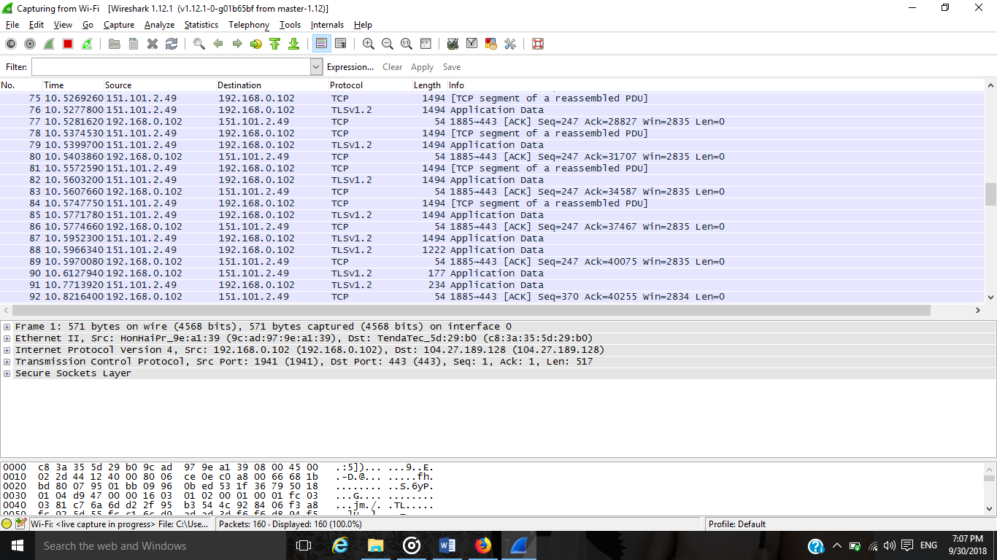

**Protocol Hierarchy: -**

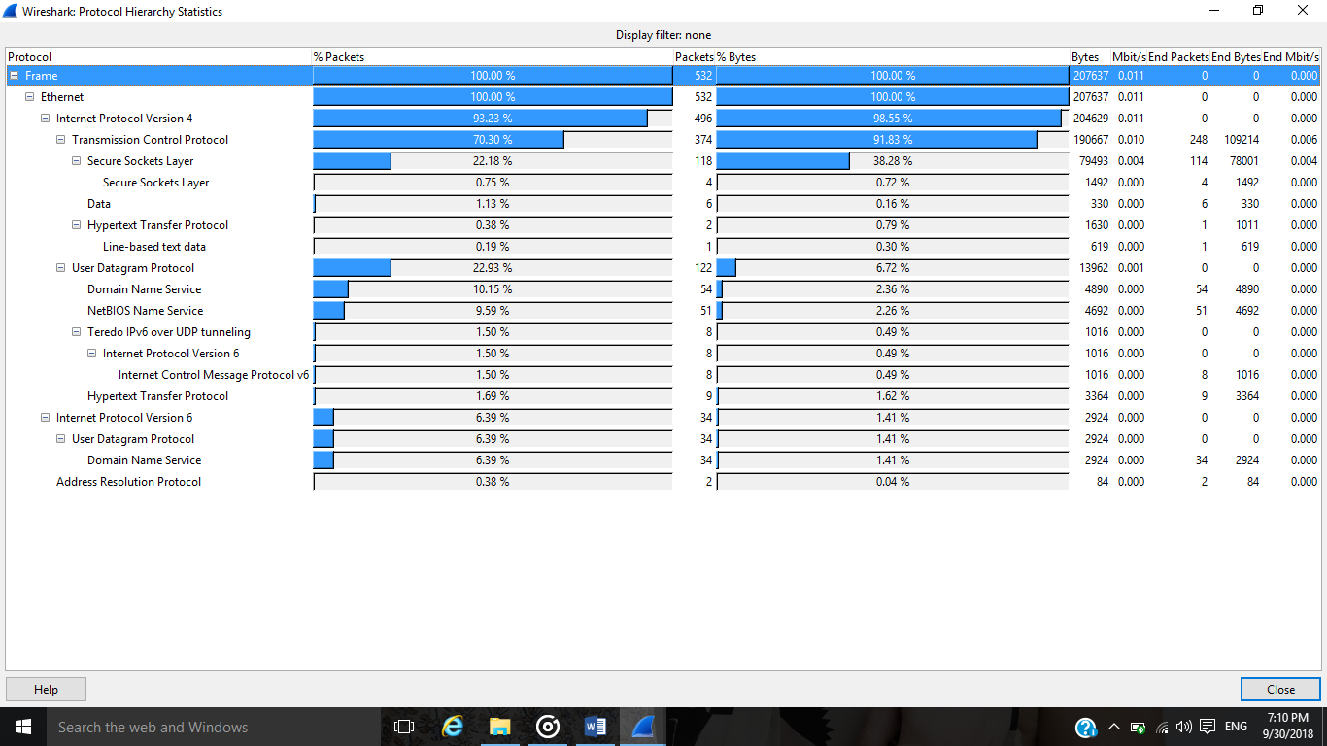

**Flow Graph: -**

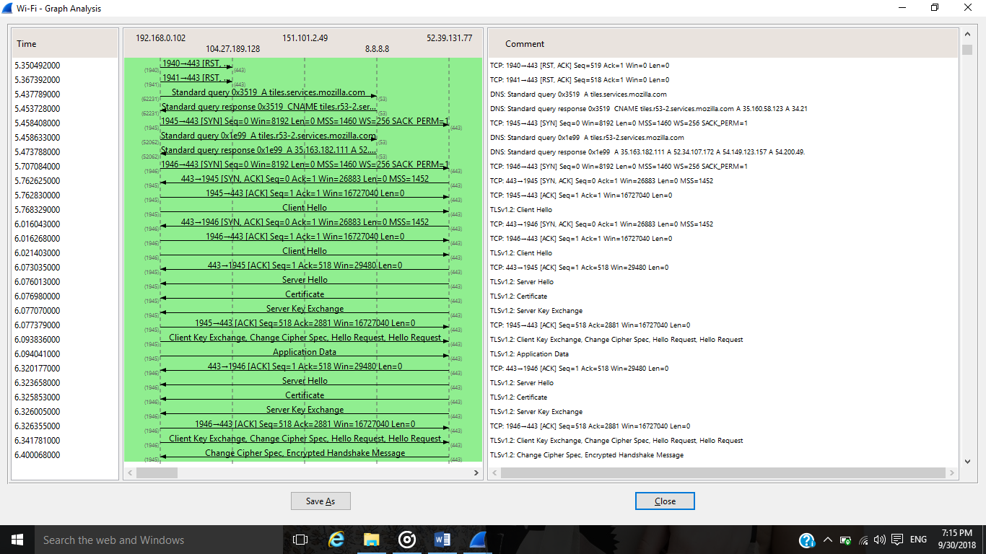

**TCP Handshaking: -**

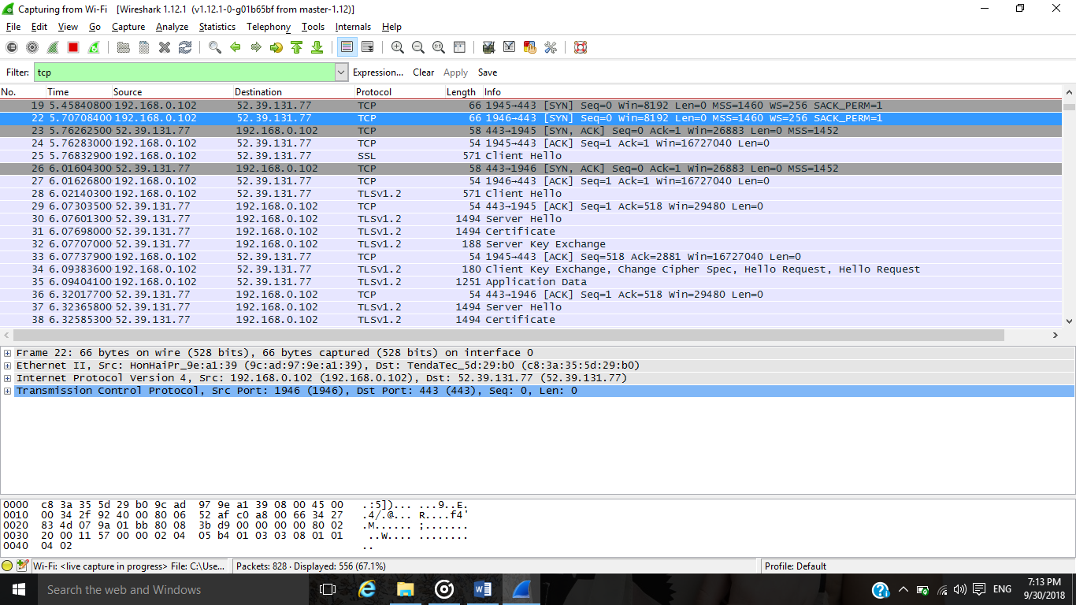

**Follow TCP Stream: -**

